**Business Analytics (**[**BU.520.601.X1.FA20**](https://blackboard.jhu.edu/webapps/blackboard/execute/courseMain?course_id=_213687_1)**)**

**Final Project Report**

**December 14th, 2020**

**Group 7: Guanjing Cao, Naina Grover, Po-Chih Hsu, and Uwella Rubuga**

**INVESTMENT PORTFOLIO FOR A SOFTWARE DEVELOPER EMPLOYEE AT AMAZON**

**Introduction**

In this project, the objective is to build an investment portfolio to maximize the returns on investment (ROI) for Mr. Nangia who is working as a software developer at Amazon. His annual income is $250,000 and has an investment budget of $150,000. He aims to diversify his investment portfolio mainly in four sectors: Technology, Retail, Finance, and Automobile sectors. We therefore chose seven stocks or companies in each of the sectors that Mr. Nangia can invest in. The stocks are chosen based on their returns and risk measures – that is, we chose stocks with higher expected returns with respect to their risk measures. In the Technology sector, the chosen stocks include Microsoft Corporation, Apple Inc, Alarm.com Holdings. Lam Research, Alphabet Inc., NortonLifeLock, and Xerox Holdings Corporation. In the Retail sector, the chosen stocks include Amazon.com Inc, eBay Inc, Coca-Cola, JD, CVS, Qurate Retail, and Pepsi. In the Finance sector, the chosen stocks include JPMorgan Chase & Co, Goldman Sachs Group Inc, Wells Fargo, Bank of America, U.S. Bancorp, S&P Global, and PNC Financials. And lastly, in the Automobile sector, the chosen stocks include Tesla Inc, Ferrari NV, Toyota, General Motors Co, Honda Motors Co Ltd, Ford Motor Company, and Harley-Davidson. Therefore, there is a total of 28 stocks that he can invest in. Mr. Nangia plans to invest larger percentages of his budget in the Technology and Retail sectors because these sectors performed well during the ongoing pandemic of COVID-19. For example, The Channel Co CRN report indicates that Apple Inc (in the tech sector) became a $2 trillion company due to increased sales in the pandemic. Moreover, the Motley Fool report shows that Amazon’s (in the retail sector) operating and net income increased to $5.8 billion and $5.2 billion in the second quarter of 2020 during COVID-19. Therefore, based on this information and his preferences, we set his portfolio such that he invests 60% of his budget in the Tech sector, 20% of his budget in the Retail sector, and the remaining 20% of his budget split equally between the Finance and Automobile sectors (i.e., 10% in each).

Additional constraints considered when building his portfolio include investment risk measures which are the Beta value and the standard deviation of each stock. Beta value measures the volatility of a stock’s price in the overall market. A value of beta higher than 1.0 indicates that the stock is more volatile than the rest of the market while a value less than 1.0 indicates that the stock is less volatile compared to the overall market. Hence, stocks of higher beta value are riskier but have the potential for higher returns while those of lower beta value have less risk with less potential returns. The limitations of using beta value as a risk measure is that it mostly indicates short-term risk as it is focused mainly on stock prices. Due to this limitation, we also examined the standard deviation (SD) of a stock’s ROI as another measure of risk in the stock market. Standard deviation of a portfolio measures the amount that the returns deviate from its mean. Like beta value, a higher SD indicates a higher volatility of the stock’s expected returns in the overall market, hence more risk as it becomes more difficult to forecast the expected returns. Such stocks do have the potential for higher returns as well. Therefore, for both beta value and standard deviation, there is a tradeoff between choosing riskier stocks with higher returns or less risky stocks with lower returns.

The data used in this project is real data collected from websites such as yahoo finance and macrotrends.net. Moreover, Mr. Nangia is a real employee at Amazon. The decision to use real data was to create an analysis and model that can be used by anyone when making decisions on which stocks to invest in.

**Mathematical Formulation**

The objective is to maximize returns on investment. When running the excel solver for linear programming, the objective function was selected as the cell containing the sum-product of the amount to be invested in each stock multiplied by the expected ROI for each stock as of 12/31/2020. ROI data for each stock was collected from the first quarter of 2018 (i.e., 03/31/2018) to the most recent third quarter of 2020 (i.e., 09/30/2020). The forecast method was used to determine the expected return for each stock as of 12/31/2020.

Moreover, in building Mr. Nangia’s investment portfolio, two categories of risk measures were considered: beta value and standard deviation. In each category, there are two options of either being a Risk Taker investor or a Risk Averse investor and determining which option provides the highest returns. In each of these categories and options, the constraints are that the whole of the $150,000 budget must be invested in one or more of the available stocks in the four sectors. 60% of the budget i.e., $90,000 must be invested in the Technology sector. 20% of the budget i.e., $30,000 must be invested in the Retail sector. 10% of the budget, i.e., $15,000 must be invested in the Finance sector, and the remaining $15,000 must be invested in the Automobile sector. The decision variables are the amounts to be invested in each sector.

**Category 1: Beta Value Risk Measure**

The weighted risk measure for each stock was calculated by dividing the sum-product of each stock with its beta value by the total sum of the amount to be invested. For a risk-taker option, the value obtained from this division will be greater than 1.0 while for a risk-averse option, the value obtained from this division will be less than 1.0.

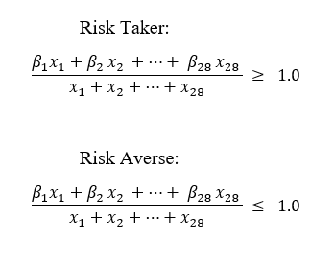

where βi is the beta value for each stock, and xi is the amount to be invested in each stock.

Since the value on the right-hand side (RHS) of the constraint is 1.0, the denominator which is the $150,000 total amount to be invested transferred to the RHS. Hence, we run two excel solvers for linear programming, one with this constraint as greater than or equal to $150,000 (*see excel sheet tab named Risk Taker (Beta >=1)*), and the other with this constraint as less than or equal to $150,000 (*see excel sheet tab named Risk Averse (Beta <=1)*). The rest of the constraints were the same for both options.

**Category 2: Standard Deviation Risk Measure**

First, the mean and the standard deviation for the ROIs from 3/31/2018 to 9/30/2020 were calculated for each stock. Then, the mean ROI values were subtracted from the expected ROI values for each stock. The obtained differences were divided by the standard deviations for each stock to determine how many standard deviations was each stock from its mean. When using beta value as a risk measure, 1.0 is a universal cutoff to determine whether a stock is risky or not. However, there is not a known cutoff for standard deviation as a risk measure. Hence, we set our own cutoff value to determine whether a stock is risky or not. If a stock’s expected ROI falls within one standard deviation of its mean, we considered it to be a safe stock (i.e., less risky) whereas if it was more than one standard deviation from its mean, then it was a risky stock (*see excel sheet tab named ROI and Beta data for the calculations*). Hence, we run two excel solvers for linear programming: Risk Taker and Risk Averse. For the Risk Taker analysis, we set a column for the risk measure binary variable as 0 for a safe stock and 1 for a risky stock, then calculated the sum-product between this variable and the amounts to be invested. An arbitrary coefficient of optimism was set as 0.7 to indicate a constraint that 70% or more of $150,000 should be invested in risky stocks whose expected ROI is more than 1 SD of their means. For the Risk Averse analysis, we changed the column for the risk measure binary variable as 1 for a safe stock and 0 for risky stock. The same coefficient of optimism was used to indicate that 70% or more of $150,000 should be invested in safe stocks whose expected ROI is within 1 SD of their means.

The next section of this report elaborates on the results from the linear programming excel solver analysis.

**Results**

**Category 1: Beta Value Risk Measure**

Comparing the results between the two options, the analysis suggests that Mr. Nangia should be more of a Risk Taker where he will gain the most returns i.e., $76,891.88 vs $44,396.03. The portfolio of which stocks to invest is different for the two options as well.

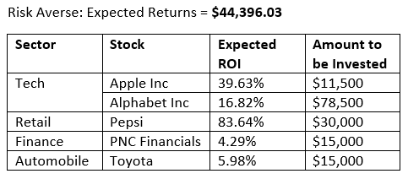

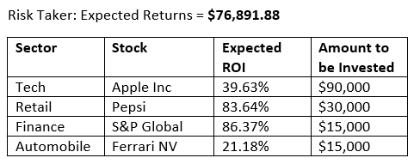

The common stocks between the two options are Apple Inc and Pepsi with the latter having the same amount to be invested of $30,000.

**Category 2: Standard Deviation Measure**

Comparing the results between the two options, the analysis also suggests that Mr. Nangia should be more of a Risk Taker where he will gain the most returns i.e., $76,891.88 vs $59,786.85. 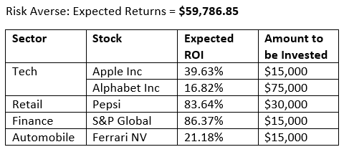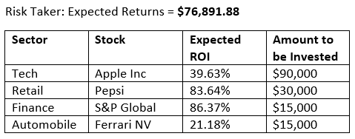The investment portfolios for both options are very similar with the Risk Averse option having an additional stock Alphabet Inc in the Tech sector which splits the $90,000 budget.

Moreover, comparing results across categories, the expected total returns for the Risk Taker option is the same when using beta value or standard deviation as a risk measure ($76,891.88). The investment portfolios are also exactly similar for the Risk Taker option in both categories. In the Risk Averse option, Mr. Nangia is expected to earn more returns when using standard deviation as a risk measure ($59,786.85 vs $44,396.03). The investment portfolios are also different with Apple Inc, Alphabet Inc, and Pepsi as the common stocks.

**Shortcomings of the model**

There are many other factors to be considered in building investment portfolios such as Stock Earnings Per Share (Stock EPS), Stock Price, Stock Volume, Total ESG (Environment, Social, Governance) Risk Score, and Recommendation ratings. These should have been added as constraints in the Linear Programming model to further strengthen the selection of the investment portfolio. Data for all these additional factors had been collected for some of the stocks but not all 28. Hence, they could not be added into the analysis.

Moreover, our model compares the beta value and standard deviation risk measures separately. Two additional analyses should be added to include both measures of risk simultaneously and compare the results for the Risk Taker and Risk Averse options to determine the one with the highest total maximized returns.

**Future Research Ideas**

Referring to the shortcomings of the model, future research ideas in the realms of this project should include the factors mentioned above as constraints to determine which stocks to be included in the investment portfolio. For example, using the recommendation ratings that we collected for some of the stocks, we ran a simulation to determine the recommendation ratings for all the 28 stocks given that they follow a normal distribution. The mean and standard deviations were calculated from the available ratings thus far in the data. The binary ratings can then be added as a constraint in the model.

Additionally, future research ideas can include changing the budget constraints to be invested in each sector to determine the sensitivity analysis of the model. This can further facilitate the determination of budgets that will increase the total expected returns. Moreover, for the standard deviation category, the coefficient of optimism can be changed to take any values between 0.5 and 1 for each option of Risk Taker and Risk Averse to determine the coefficient with the highest total returns. And as mentioned earlier, both risk measures can be evaluated simultaneously. And lastly, more stocks and sectors can also be included in future research ideas.

**Conclusion**

Given the $150,000 budget, we recommend that Mr. Nangia should be more of a risk taker where he will gain the most returns from his investment. We also recommend that he uses standard deviation as a measure of risk because it measures long-term risk, and with respect to our analysis, it resulted in similar returns for the risk taker option and higher returns for the risk averse option compared to the beta value risk measure.

Based on these recommendations and Mr. Nangia’s budget, our suggested investment portfolio includes Apple Inc, Pepsi, S&P Global, and Ferrari NV.

References:

# Alspach, K. “Apple Becomes A $2 Trillion Company As Strong Sales Buck The Pandemic.” (August 2020) DOI: <https://www.crn.com/news/mobility/apple-becomes-a-2-trillion-company-as-strong-sales-buck-the-pandemic>

Beers, B. “How is Standard Deviation Used to Determine Risk.” (October 2020). DOI: <https://www.investopedia.com/ask/answers/021915/how-standard-deviation-used-determine-risk.asp>

McClure, B. “What Beta Means When Considering a Stock’s Risk.” (February 2020). DOI: <https://www.investopedia.com/investing/beta-know-risk/#:~:text=A%20stock%20that%20swings%20more,risk%20but%20also%20lower%20returns>.

Morning Star, Inc “Standard Deviation.” (2015). DOI: <http://news.morningstar.com/classroom2/course.asp?docid=2927&page=2>

# Noonan, K., et al. “These 3 Tech Stocks Are Huge Winners of the Coronavirus Pandemic.” (September 2020). DOI: <https://www.fool.com/investing/2020/09/06/these-3-tech-stocks-are-huge-winners-of-the-corona/>

Data Sources :

MacroTrends. DOI : <https://www.macrotrends.net/>

Date Obtained: 12/10/2020

Yahoo Finance. DOI : <https://finance.yahoo.com/>

Date Obtained: 12/10/2020